Search and Go

Alaa Azazi

*alaa.azazi@ucalgary.ca*

Gellert Kispal

*kispalgellert@gmail.com*

Sydney Pratte

*sydney.pratte@hotmail.com*

Table of Contents

Section 1: Identification and Requirements 2

Background Environment 2

What the System Will Be Used For 3

System Constraints 3

Personal Constraints: 3

Sport Chek’s Constraints: 4

Identification 4

Expected Users 4

Work Context 5

Concrete Task Examples 5

Tentative List of Requirements 9

Must Include: 9

Should Include: 9

Could Include: 9

Exclude: 10

Section 2: Prototyping and Walkthrough 10

Low Fidelity Prototype 10

Walkthroughs 18

Task 1 Example Walkthrough: 18

Task 2 Example Walkthrough: 20

Task 3 Example Walkthrough: 21

Task 4 Example Walkthrough: 23

Task 5 Example Walkthrough: 25

# Section 1: Identification and Requirements

## Background Environment

Our group is a part of Dr. Maurer’s research team in the Agile Software Engineering lab. In the lab, we are currently working on the Brigade project, a system aimed to introduce a multi-surface environment into retail spaces. The system will allow users to interact with product information across different devices, such as tabletops, iPhones and wall displays. This idea is what inspired our group. We will scale the Brigade project down and implement an interactive information kiosk for a retail environment.

In order to simplify our task we decided to customize our system, Search and Go, specifically for Sport Chek. Sport Chek is the largest Canadian retailer of sporting goods with locations all across Canada. We chose Sport Chek due to the companies size and variety of merchandise offered. Large stores with a variety of products are difficult for customers to navigate. It is also difficult for the customers and employees to find products quickly. Currently, Sport Chek employees use a console-based system running on Windows 2000 to look up product information. These systems are slow and only accessible to the employees. The systems used for searching are the same systems used for purchasing items and are located at the cash desks. Therefore if a customer wants information on an item they must seek the assistance of a sales associate who must, in turn, wait for an available computer to use. The current system also requires the search criteria to be very specific, the employee needs to know the product’s exact name or the “UPC” code. Employees at Sport Chek say that, most often, if they do not have the product name or UPC code, it is faster to manually search the store for the item. The above-described issues are reasons for which a system like ours could improve the overall workflow of the retail store. The goal of our system is to enhance the customer experience and to help employees work more efficiently.

## What the System Will Be Used For

The Primary use of our system is searching and viewing product information. With our system customers and employees will be able to quickly check product information such as availability, location, description, ratings and reviews, price, sales and similar items. Users can browse categories such as sale items and customers can request the help of an employee. The main purpose of our system is for the users to access desired information fast and efficiently. The system will not be used to completely replace the current system because it is not intended for the sale of goods. Our system is intended to be running on computers placed throughout the store for speedy access. The general expectation of our system is that users will be able to access product information fast and easily. In other words, our system is expected to be more efficient to use to search for products than the current system and more efficient than manually searching the store.

## System Constraints

### Personal Constraints:

We as a group face various factors that will constrain our system and limit the design. As per the course requirements, we will be developing our system in C# using Visual Studio 2010 therefore our system will only be able to run on a Windows computer. Since this is a course project we have no budget so we are limited to the resources we can access for free, such as the computers in the tutorial room. We are also limited by time, in the sense that the project must meet deadlines specified in the course outline.

### Sport Chek’s Constraints:

If a company as large as Sport Chek brought in our system they would have much different constraints on the system that would limit the design. They would have to have a large enough budget to install a few kiosks in all their locations. It would have to be compatible with their database and it would have to be implemented in both English and French since they are a national retailer.

## Identification

### Expected Users

Our expected users can be broken down into two groups:

* Customers
* Employees

Customers may be any one from the general public. The general public includes adults, seniors, teenagers, children, people with disabilities (visual, hearing, physical), non-English speakers and people with varying levels of technical competence and exposure to computers. The target customer users of Search and Go are English speaking people ages 12 to 65 with basic computer skills. The customer users of Search and Go are expected to know how to use an external keyboard.

Employees can be new staff, more experienced staff, or managers. Employees who are helping customers are the expected users of the system. They must have the same basic skills with a computer as a customer and require little to no special training.

People with disabilities will be excluded from the design because they are infrequent users and require special equipment, which is beyond the scope of this project. We will also exclude Non-English or non-French speaking people because Sport Chek is only located in Canada. We are also excluding seniors who have no experience with computers and children under the age of 12 (with the assumption that they will be accompanied by a parent or guardian who will interact with the system).

### Work Context

Search and Go is designed to enhance customer experience by providing a method for shoppers to inquire about products without the necessity of a sales associate. Therefore customers seeking to learn more about an item will primarily use the system along with employees who are assisting customers that may wish to not interact with a computer.

### Concrete Task Examples

Our tasks were collected in a few ways. First we went to a few Sport Chek locations. At each location we observed how people shopped in the store as it currently is, in order to see what kind of people come in and their shopping patterns. We then talked to a few customers and asked them how they liked the store layout, if products were easy to find and what kind of information they would like to see in a system like the one we are making. We also spoke with employees, asking them about the current system and what they thought would be useful for them. Next we went to Chapters because they have an information kiosk very similar to the system we are making in place at their locations. Again we first observed how people interacted with the system noting typical behaviors, difficulties and expectations. Then we talked to the customers and the employees asking them how they liked the system, how it could be improved and how easy they found it to use.

Our findings from our observations and the feedback we gathered from talking to users led to the following task examples:

Task Example 1:

* + - Willard is an older man looking to buy a pair of runners that his granddaughter recommended to him. He has the name of the company and a picture but does not know any other product information. He goes to a local Sport Chek, finds a kiosk and types in the name of the company and specifies “shoes”. He finds the right style and sees they are in stock in his size. He then requests the assistance of a sales associate. When the sales associate arrives he notes the shoe style and size then takes Willard to the shoe section, retrieves the shoe from the back storage and gives them to Willard to try on. Willard likes the fit so he takes the shoes to the front of the store and pays cash for them. Willard knows how to work a computer but he is not very “tech savvy”. He also does not like to spend a lot of time shopping.

Discussion:

* This is an example of a routine task, as validated by a Chapters employee, and observations. At Chapters many people come into the store and immediately go to a kiosk to search for an item. Many people also do not have exact information. Sport Chek employees also validated this task as routine. Many customers come in and want to know specific information like size and availability and they require assistance.
* Willard is an example of a typical user. He is familiar with computers but not necessarily proficient with them. He knows what he is looking for but not all the specific information. He wants to accomplish his task quickly.

Task Example 2:

* + - Erica is a sales associate at Sport Chek. She often has customers come to her and request information about items. In this situation, Erica has a customer come to her and ask if they have any women’s black Adidas hoodies in size small. Erica takes the customer to a kiosk and searches for black Adidas hoodies size small. The customer points out the one she is looking for but notices it is not in stock at that location. Erica shows her which locations have it in stock; the customer thanks her and leaves to go to the other location.

Discussion:

* + - Erica introduces the Sport Chek employees as a user of the system. Employees are often required to do searches in order to find specific information like size, stock, colours, etc. If the store is busy these searchers need to be done quickly.
    - This task is frequent and important because employees encounter this several times a day and many people want to know specific information on a product. This task also shows how some customers may not want to interact with the system directly but instead, through an employee. This could be because of a disability or because they are not comfortable/familiar with computers or touch based systems.

Task Example 3:

* + - Kevin is a young adult who regularly comes into Sport Chek to see the new products. Kevin does not want to over look an item he may like by browsing the entire store so he goes to an information kiosk to see what is new. At the kiosk he selects the new items to browse. While browsing, he sees that Under Armour, a brand he likes, has a new style of shirt. Kevin selects the shirt and sees that it has 3 available colours. He selects the blue colour to view and he sees that they have his size at this location. Kevin is not sure if he will like the colour in person so he notes where in the store it is located and goes to see the shirt. Once he finds the shirt he sees that he does like the colour. He then finds his size, takes it to the till and pays with debit. Kevin does a lot of shopping online and is comfortable with browsing items on a computer system.

Discussion:

* + - Kevin is an example of a more occasional user. The majority of the people using the system will be searching for product information on a specific item (as observed with the Chapters system). There will be fewer users who use the in store system just to browse.
    - However, this task is an important task because people like to have fast access to new and sales items.

Task Example 4:

* + - Becky is an 18-year-old recreational volleyball player. Becky comes in to Sport Chek to purchase new kneepads. This is her first time shopping at this location in a while so she goes to the information kiosk to see what kneepads the store has and where they are located. At the kiosk she searches for kneepads and browses the results. She sees that there are a few results that match what she is looking for. She wants to compare 3 of them so she adds them to the compare list and views their features all at once. She sees that one pair has the best price and the best reviews from the three and they are in stock so she looks up where exactly they are in the store and goes to find them. Once she finds the right pair she takes them to the front and pays with debit.

Discussion:

* + - Becky is an example of typical user because she is very familiar with computers and knows how to navigate them easily. She is also an example of a typical user because she does not shop at Sport Chek very often and is unfamiliar with the current layout of the store.
    - This task is and example of an infrequent but still important task. Not many people will want to stand at a kiosk for a long(ish) time to find items and compare them, but it is important because the customers who like to compare items will really value this feature. A lot of people like to compare shop but they may not like to do this at a stand up kiosk.

Task Example 5:

* Amy is an adult woman who comes to Sport Chek with no real purpose in mind. She sees a kiosk and decides to look through the promotions. She selects the 50% off promos and casually browses the items, she finds something that looks interesting but after viewing it further she decides it is not something she wants to buy. She goes back to browsing but does not find anything else of interest so she leaves the store.

Discussion:

* Amy is a less frequent user. Most people who use the system will have some sort of goal in mind when they start to use the kiosk.
* This task is an example of a less frequent but still important. Our kiosk will be a good means for the store to advertise their current promotions. Also this is the kind of information users would expect the system to have.

## Tentative List of Requirements

### Must Include:

* User can search for an item.
* User can specify search criteria.
* User can view product information.
* User can browse new items.
* User can browse sale items.
* User can browse categories.

The above features are the most important features in our system. They outline the most basic functionality that users will expect. The omission of any of these features in our system will depreciate its value significantly.

### Should Include:

* Users can check the availability of items at multiple locations.
* User can view item section location on a map of the store.
* Users can request assistance from an employee.
* System displays current promotions.

These features are extensions of the main features. Most users would be able to complete their tasks with out these features but their addition to the system will enhance the users experience.

### Could Include:

* User can purchase an item.
* User can sign in/register for an account.
* User can register team for Team Assist program.
* User can use Team Assist card when making a purchase.
* User can view other store locations on a map.
* User can get directions to other store locations.
* User can have a wish list.
* User can change the text size.
* User can send wish list from phone app to kiosk.

The above features are infrequent and unnecessary to the system’s functionality but are valuable to subsets of users. These are the features that we will implement after the features in the must and should include sections, if time permits.

### Exclude:

* Users can compare items.
* Support for French

We choose to exclude the first feature because very few people would use Search and Go for this purpose. We also choose to exclude it because of Sport Chek’s variety of merchandise offered; it would be difficult to implement comparisons that make sense with all items other then just a list. The last feature we are excluding because it is not required for this project. However, we will implement a “dummy button” for this feature because of its important in a real life system.

# Section 2: Prototyping and Walkthrough

## Low Fidelity Prototype

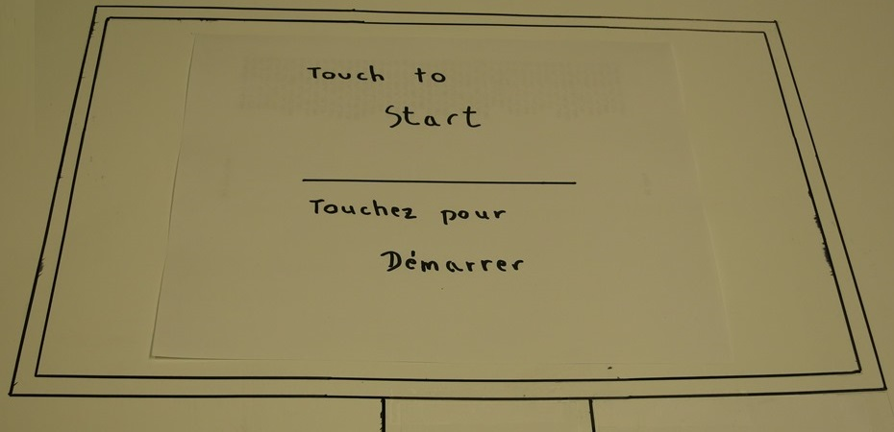

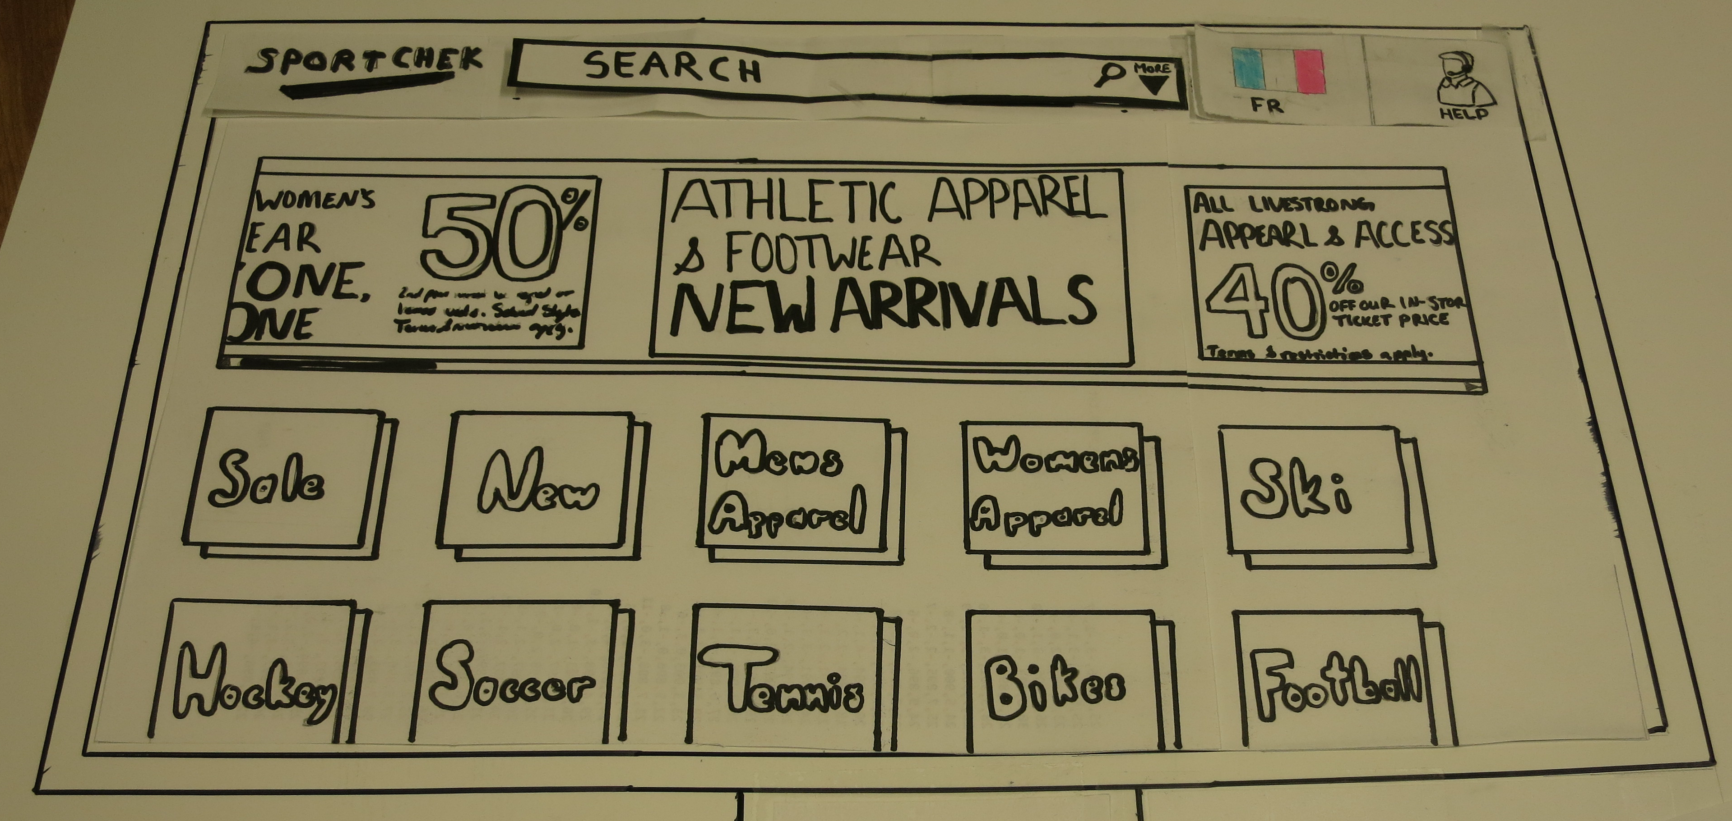

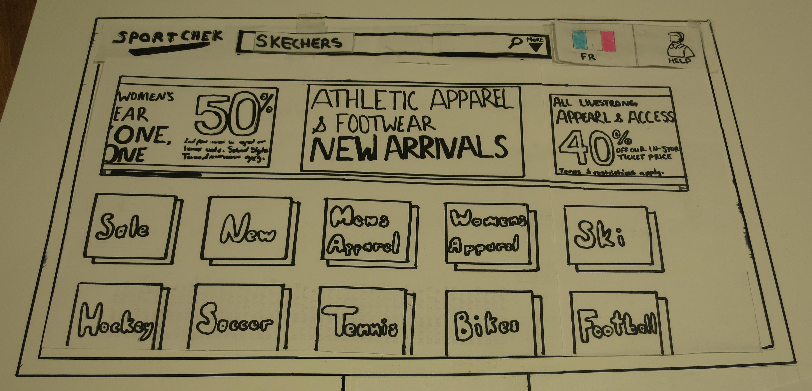

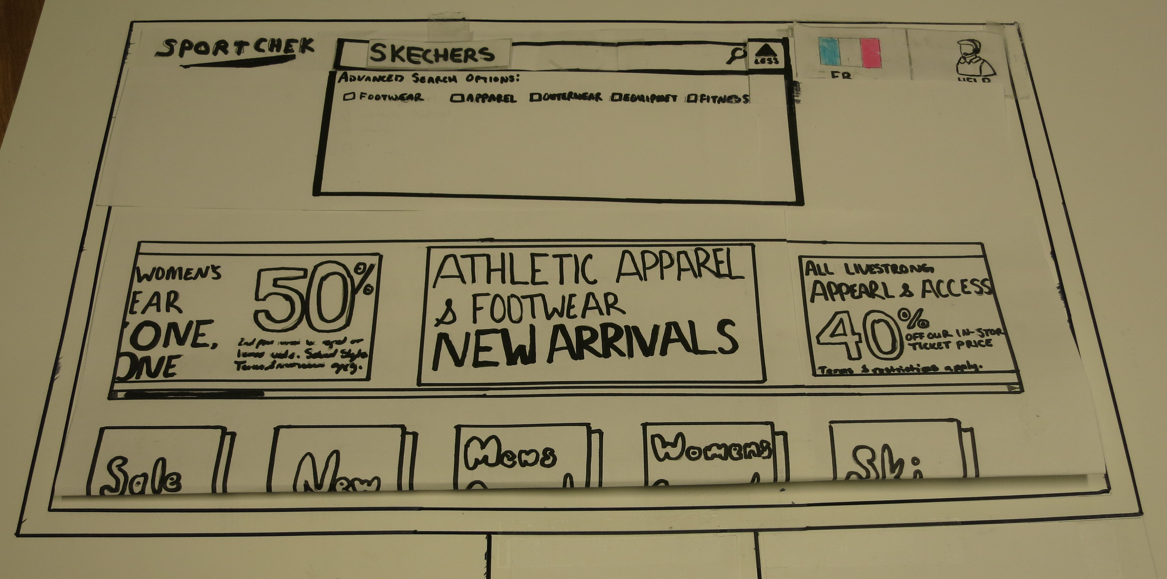

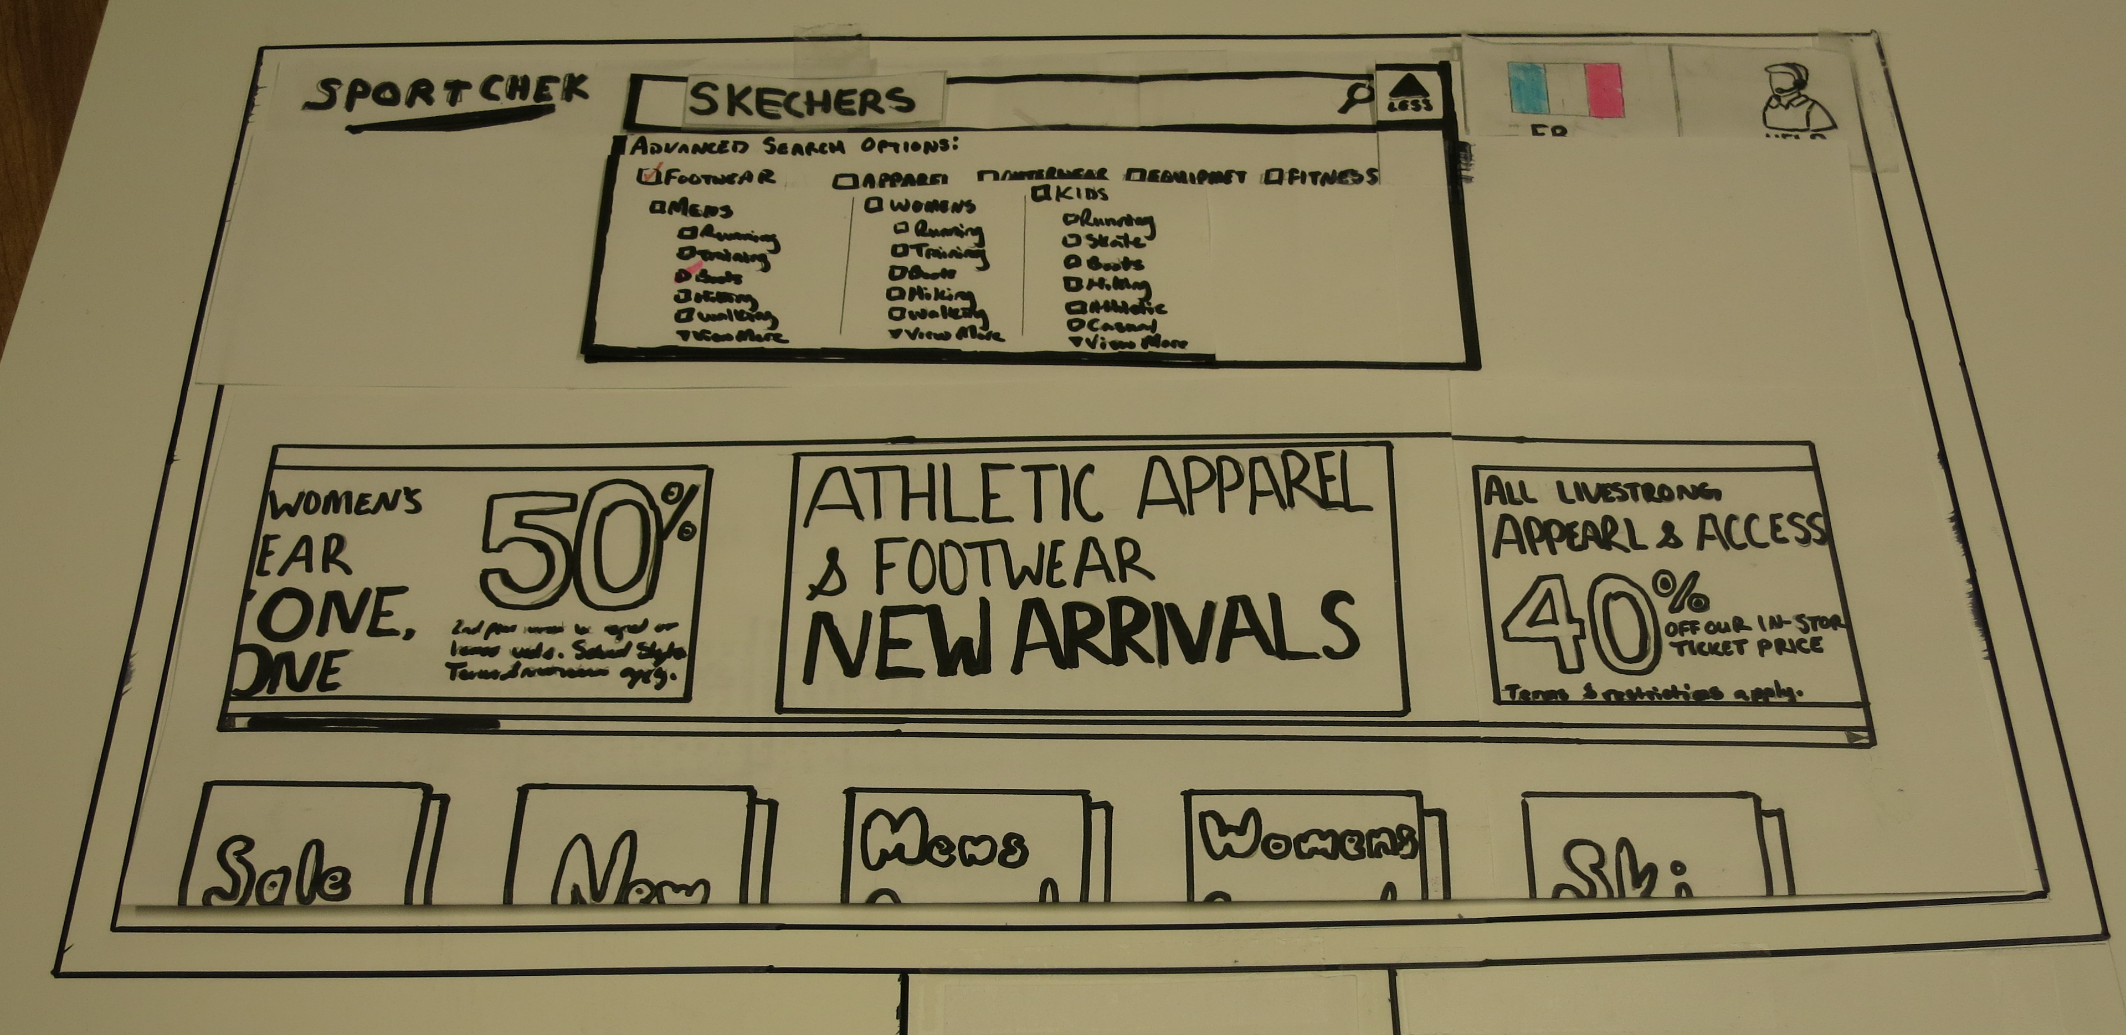

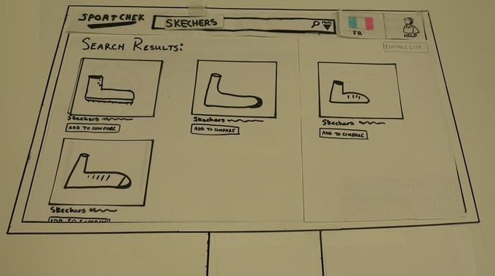

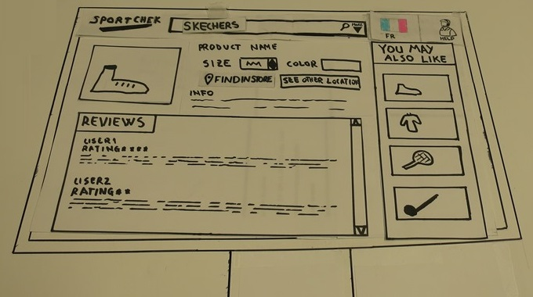

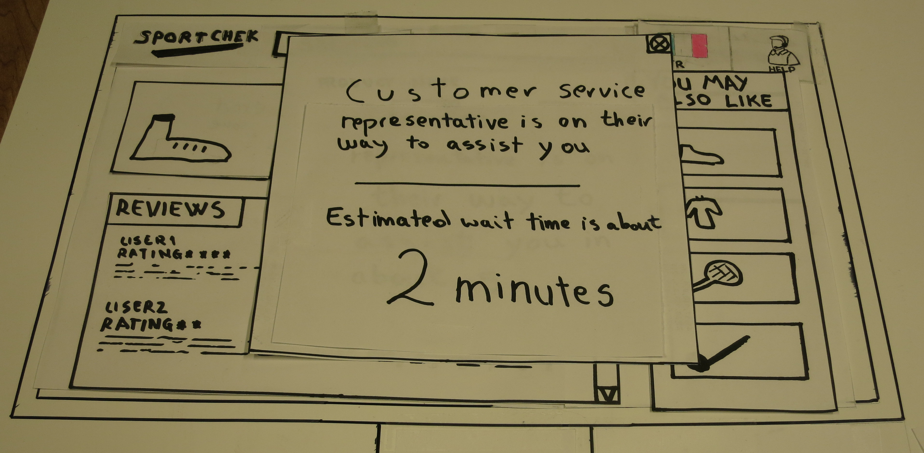

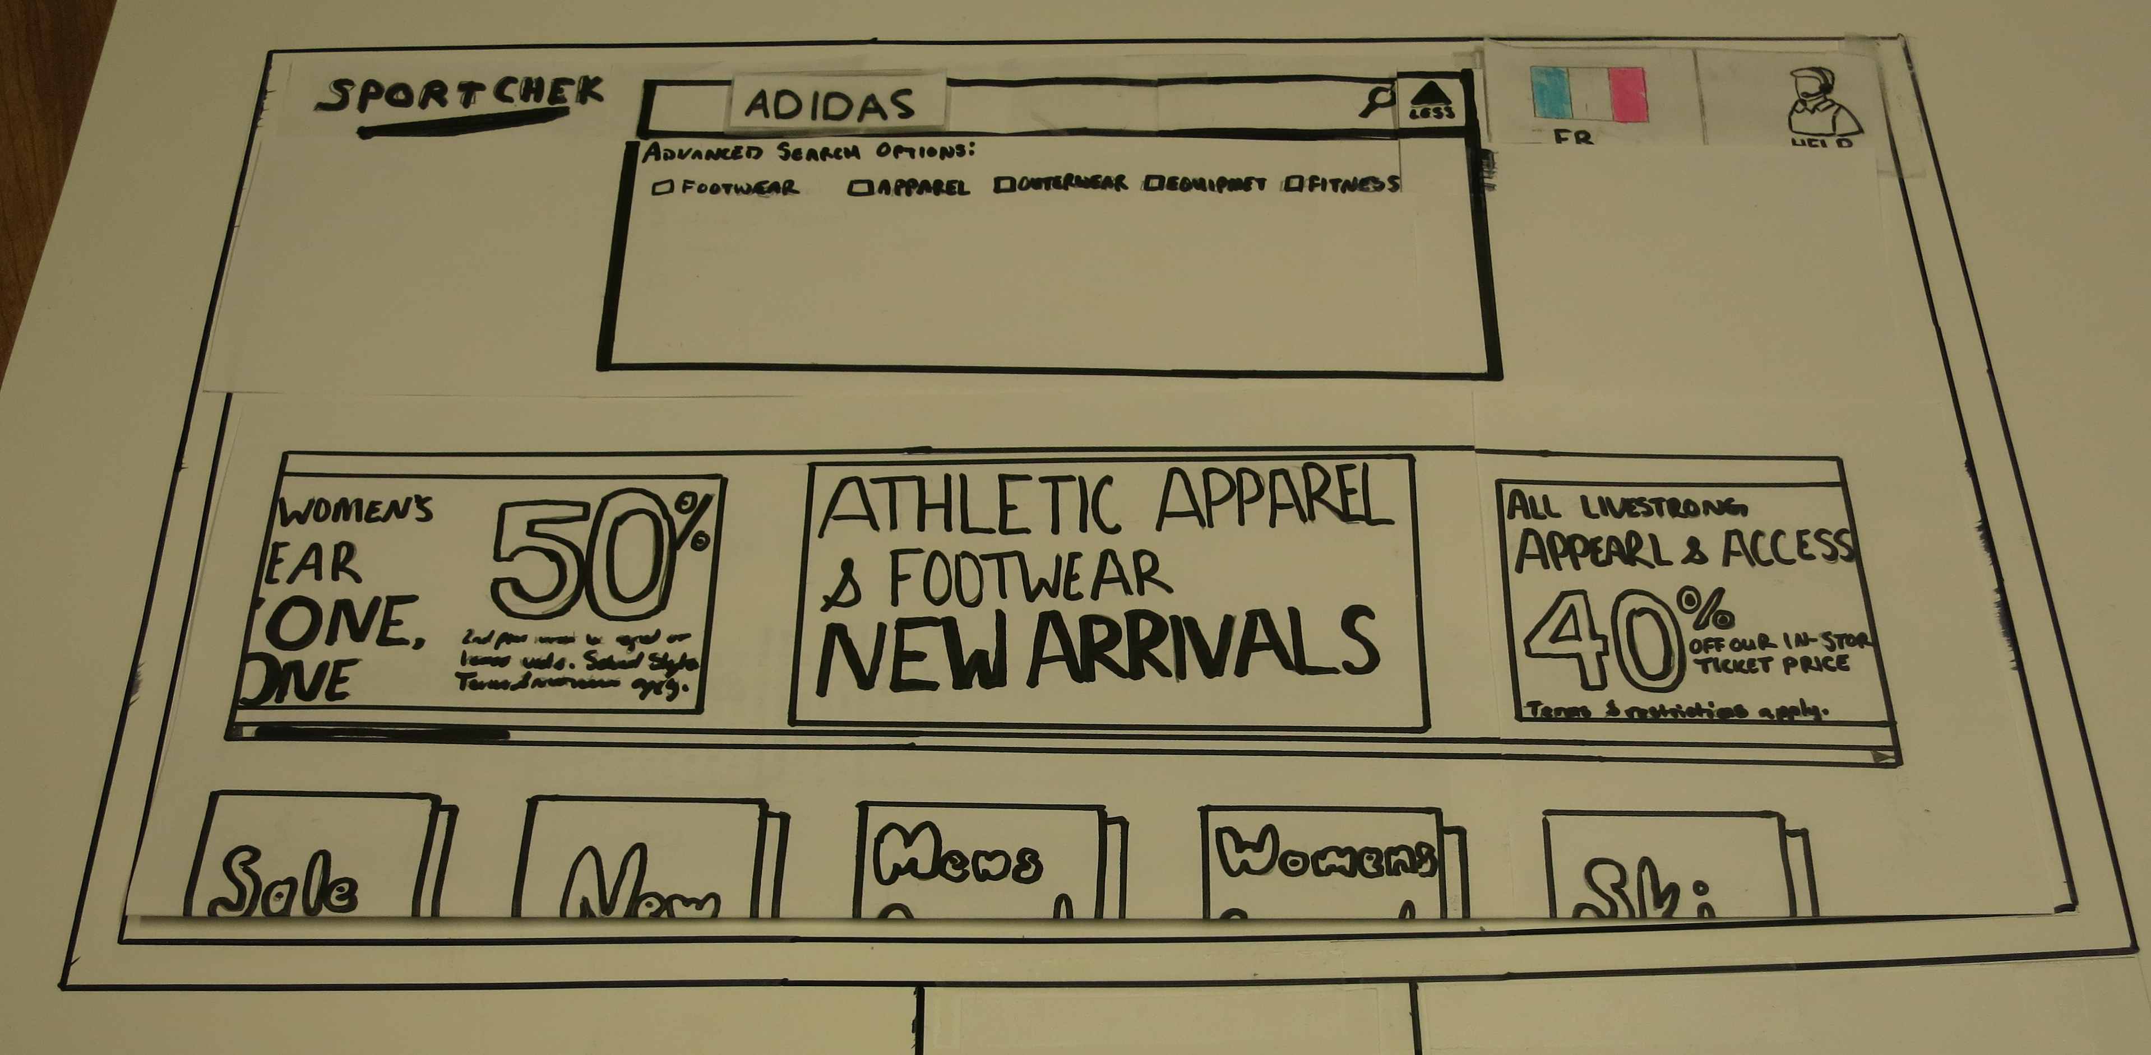

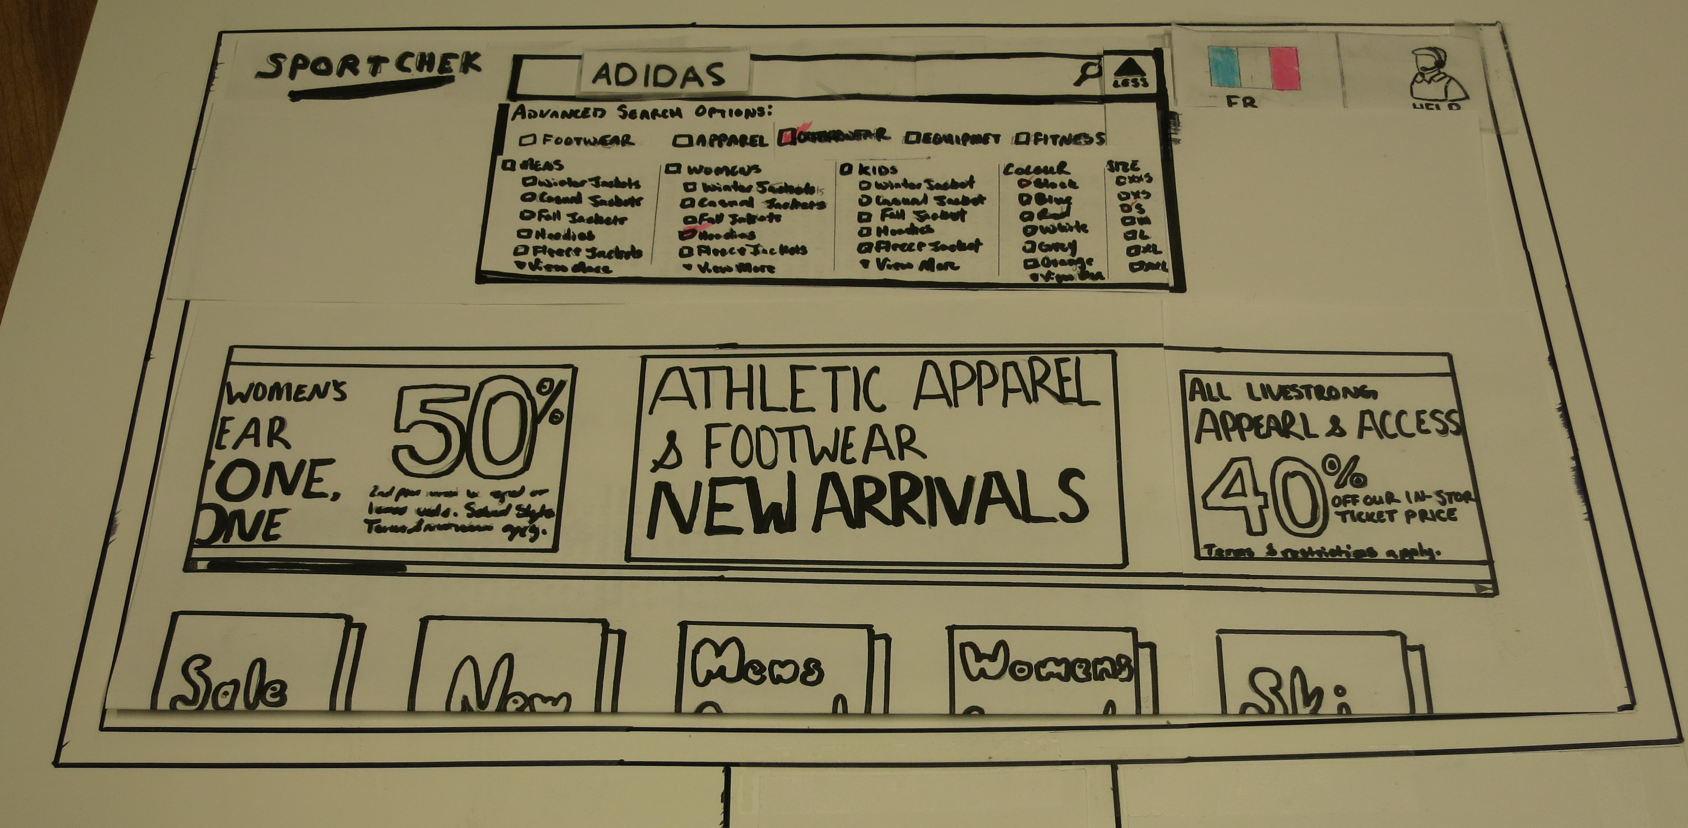

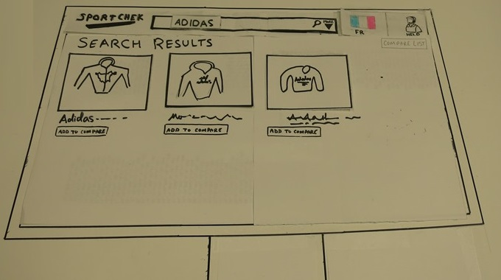

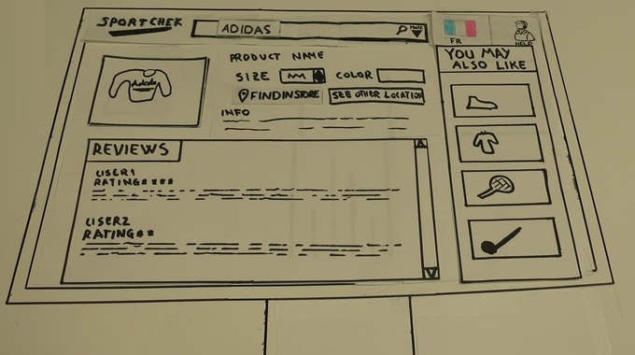

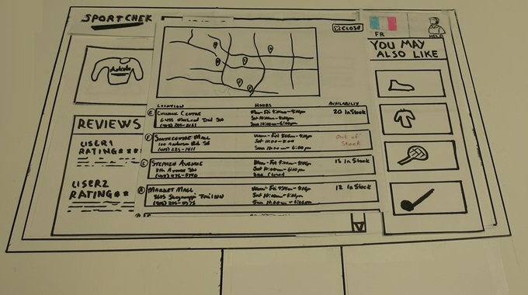

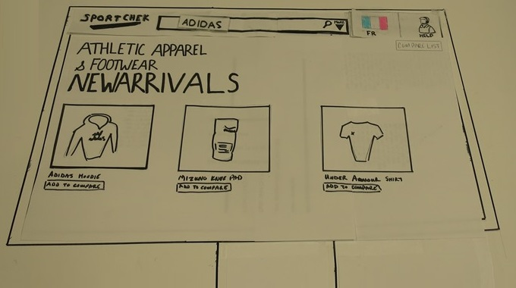

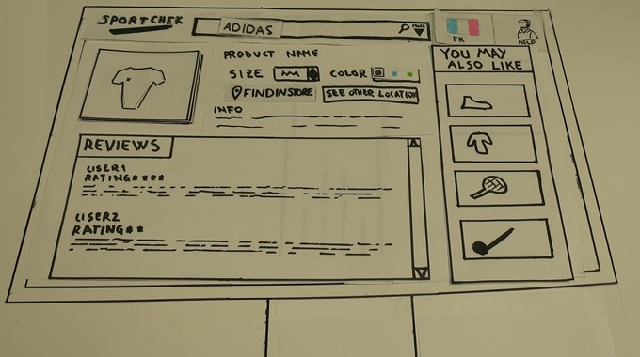

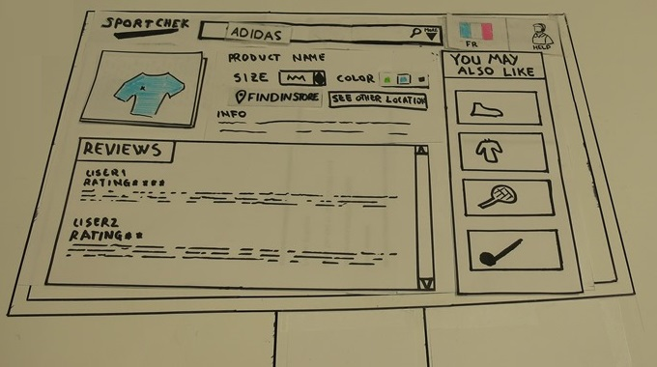

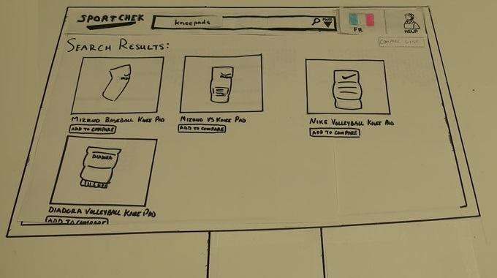

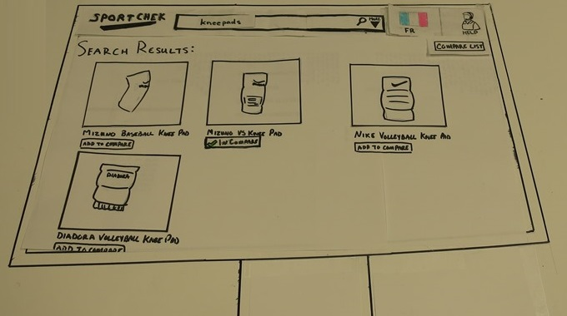

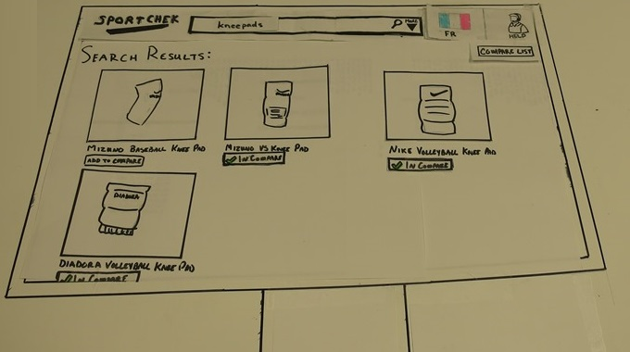

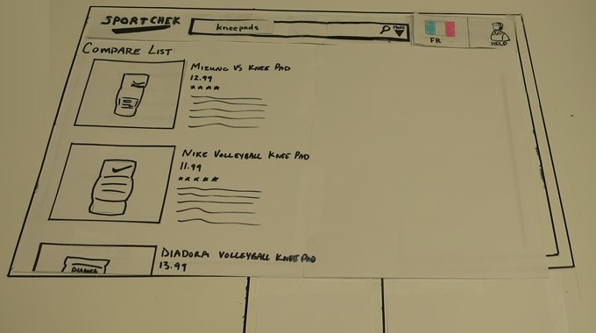

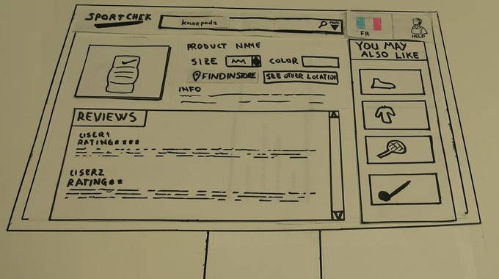

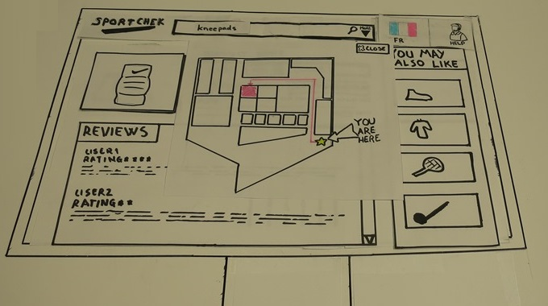

## Walkthroughs

### Task 1 Example Walkthrough:

|  |  |  |  |  |
| --- | --- | --- | --- | --- |
| **Step#** | **Description** | **Knowledge/Training?** | **Motivated** | **Comments** |
| 1 | Willard enters the store | Yes | Yes (he wants to buy new runners) |  |
| 2 | Looks for a kiosk | Modest Problem | Modest Problem | Unfortunately, we do not know how the store plans to tell customers about the new information kiosks.  Some users might also not be motivated to look for a kiosk, especially if the store is big.  A possible solution will be to install multiple kiosks in different apparent sections of the store and mark them clearly as “information kiosks”. |
| 3 | Touches the screen to start | Yes | Modest Problem | Certain people might not want to use the new system, and would rather talk to a representative directly. Other people might not like the touch approach for hygienic reasons.  A possible solution is to install sanitation stations next to the information kiosks. |
| 4 | Enters the company name and chooses shoes from the more down-arrow menu | Modest Problem | Yes (He wants to find the shoes) | Willard might not be familiar with the advanced search menu or might not realize it is there.  Alternatively, users can enter keywords (such as shoes, hoodies, colors, sizes, etc) in the search bar, and the system will use these words to filter the search results accordingly. |
| 5 | Browses the search results | Yes | Modest Problem | The search might return a long list of items, and it could be difficult for Willard to browse through all of them.  As a solution, the system shows a maximum of 10 items per page. |
| 6 | Select the right shoes | Yes | Yes |  |
| 7 | Reads the product info and finds that it is in stock | Yes | Yes |  |
| 8 | Clicks the help button | Modest Problem | Modest Problem | Willard might not know what the help button is used for (technical help, customer service, etc).  As a solution, the help button is implemented as a flashing customer representative icon to emphasize its meaning. |
| 9 | Waits for representative | Yes (the system notified Willard that a representative will be with him shortly and gives a time estimation) | Motivation low | Certain users do not like to wait, especially if all representatives are busy which translates into longer wait periods.  As a solution, the system informs the users of the estimated waiting time (based on how busy the store is). |
| 10 | Walks with representative to the shoes section | Yes | Yes |  |
| 11 | Try shoes on | Yes | Yes |  |
| 12 | Takes the shoes to the counter | Yes | Yes |  |
| 13 | Pays for the shoes | Yes | Yes |  |

* Willard was able to perform the task on the new system smoothly (in general)
* Problems he faced :
  + Store-related (such as finding the information kiosk, and waiting for representatives in a crowded store),
  + Matters of personal preference (such as choosing not to touch the screen).
* The system considers:
  + Technical issues such as the number of search results in each page
  + The ability to use multiple search keywords to ensure its user-friendliness for wide variety of users.

### Task 2 Example Walkthrough:

|  |  |  |  |  |
| --- | --- | --- | --- | --- |
| **Step#** | **Description** | **Knowledge/Training?** | **Motivated** | **Comments** |
| 1 | Erica is asked by a customer for women’s black hoodies in size small | Yes | Yes (as it is part of her duty) |  |
| 2 | Looks for a kiosk | Yes | Yes (to help the customer) | Assuming that Erica has worked in the store long enough, and knows the location of the information kiosk(s) within the store. |
| 3 | Touches the screen to start | Yes | Modest Problem | Erica might not like the touch approach for hygienic reasons. |
| 4 | Enters the company name and chooses women’s hoodies from the more down-arrow menu | Yes | Yes |  |
| 5 | Browses the search results | Yes | Modest Problem | The search might return a long list of items, and it could be difficult for Willard to browse through all of them.  As a solution, the system shows a maximum of 10 items per page. |
| 6 | Select the item chosen by the customer | Yes | Yes |  |
| 7 | Reads the product info and finds that it is out of stock | Yes | Yes |  |
| 8 | Clicks on “See other locations” | Yes | Yes | Assuming Erica has been trained on using the information kiosk. |
| 9 | Notes the availability info in other locations for customer | Yes | Yes |  |
| 10 | Greets the customer as she leaves the store | Yes | Yes |  |

* Erica was able to efficiently perform the task on the new system
* Assuming Erica has been trained on using the new system and is familiar with the layout of the store
* Problems faced were matters of personal preference (choosing not to touch the screen).
* The system considers:
  + Technical issues such as the number of search results in each page
  + The ability to use multiple search keywords to ensure its user-friendliness for wide variety of users.

### Task 3 Example Walkthrough:

|  |  |  |  |  |
| --- | --- | --- | --- | --- |
| **Step#** | **Description** | **Knowledge/Training?** | **Motivated** | **Comments** |
| 1 | Kevin enters the store | Yes | Yes (he wants to see what's new) |  |
| 2 | Looks for a kiosk | Modest Problem | Modest Problem | Kevin might not know that the store started to use kiosks. Unfortunately, we do not know how the store plans to tell customers about the new information kiosks.  Some users might also not be motivated to look for a kiosk, especially if the store is big.  A possible solution will be to install multiple kiosks in different apparent sections of the store and mark them clearly as “information kiosks”. |
| 3 | Touches the screen to start | Yes | Modest Problem | Certain people might not want to use the new system, and would rather talk to a representative directly. Other people might not like the touch approach for hygienic reasons.  A possible solution is to install sanitation stations next to the information kiosks. |
| 4 | Clicks the New Arrivals category | Yes | Yes |  |
| 5 | Browses the search results | Yes | Modest Problem | The search might return a long list of items, and it could be difficult for Kevin to browse through all of them.  As a solution, the system shows a maximum of 10 items per page. |
| 6 | Selects the Under Armour shirt | Yes | Yes |  |
| 7 | Reads the product info and checks available colors and sizes | Yes | Yes |  |
| 8 | Clicks on “Find in store” to show a map of the store highlighting the item section | Modest Problem | Yes (He wants to try it on) | Kevin might not know what the button is used for. As a solution to this problem, the button will have a map icon to indicate that it opens a map. |
| 9 | Notes the location of the section from the map | Yes | Yes |  |
| 10 | Walks to the section | Yes | Yes | Assuming Kevin remembers the location from the map. |
| 11 | Tries the shirt on | Yes | Yes |  |
| 12 | Takes the shirt to the counter | Yes | Yes |  |
| 13 | Pays for the shirt | Yes | Yes |  |

* Kevin was able to perform the task on the new system smoothly.
* The problems faced:
  + Store-related (such as finding the information kiosk, and finding the right section)
  + Matters of personal preference (such as choosing not to touch the screen).
* The system considers:
  + Technical issues such as the number of search results in each page
  + Implements standard and widely used interactions to ensure its user-friendliness for a wide variety of users.

### Task 4 Example Walkthrough:

|  |  |  |  |  |
| --- | --- | --- | --- | --- |
| **Step#** | **Description** | **Knowledge/Training?** | **Motivated** | **Comments** |
| 1 | Becky enters the store | Yes | Yes (she wants to buy new kneepads) |  |
| 2 | Looks for a kiosk | Modest Problem | Modest Problem | Becky might not know that the store uses kiosks. Unfortunately, we do not know how the store plans to tell customers about the new information kiosks.  Some users might also not be motivated to look for a kiosk, especially if the store is big.  A possible solution will be to install multiple kiosks in different apparent sections of the store and mark them clearly as “information kiosks”. |
| 3 | Touches the screen to start | Yes | Modest Problem | Certain people might not want to use the new system, and would rather talk to a representative directly. Other people might not like the touch approach for hygienic reasons.  A possible solution is to install sanitation stations next to the information kiosks. |
| 4 | Enters "kneepads" in the search bar | Yes | Yes |  |
| 5 | Browses the search results | Yes | Modest Problem | The search might return a long list of terms, and it could be difficult for Becky to browse through all of them.  As a solution, the system shows a maximum of 10 items per page. |
| 6 | Click the "add to compare list" button below each of the items she's interested in | Modest Problem | Yes (She wants to compare the results) | Although the buttons seem self-explanatory, the usual method of comparison on computers is using check-boxes. However, since the kiosk will have a touch-based interface, it will be harder for users to check boxes. The button will also provide feedback by displaying a check mark and changing the text on the button to "added to compare list". |
| 7 | Clicks the compare items button | Yes | Yes |  |
| 8 | Chooses the best item in the comparison window and notes that it is in stock | Yes | Yes |  |
| 9 | Clicks on “Find in store” to show a map of the store highlighting the item section | Modest Problem | Yes | Becky might not know what the button is used for. As a solution to this problem, the button will have a map icon to indicate that it opens a map. |
| 10 | Notes the location of the section from the map | Yes | Yes |  |
| 11 | Walks to the section | Yes | Yes | Assuming Becky remembers the location from the map. |
| 12 | Takes the item to the counter | Yes | Yes |  |
| 13 | Pays for the item | Yes | Yes |  |

* Becky was able to perform the task on the new system smoothly
* Problems faced:
  + Store-related (such as finding the information kiosk, and finding the right section)
  + Matters of personal preference (such as choosing not to touch the screen).
* The system considers:
  + Technical issues such as the number of search results in each page
  + Implements touch-oriented interactions to ensure its user-friendliness for a wide variety of users.

### Task 5 Example Walkthrough:

|  |  |  |  |  |
| --- | --- | --- | --- | --- |
| **Step#** | **Description** | **Knowledge/Training?** | **Motivated** | **Comments** |
| 1 | Amy enters the store | Yes | Yes (she wants to check current promotions) |  |
| 2 | Looks for a kiosk | Modest Problem | Modest Problem | Amy might not know that the store uses kiosks. Unfortunately, we do not know how the store plans to tell customers about the new information kiosks.  Some users might also not be motivated to look for a kiosk, especially if the store is big.  A possible solution will be to install multiple kiosks in different apparent sections of the store and mark them clearly as “information kiosks”. |
| 3 | Touches the screen to start | Yes | Modest Problem | Certain people might not want to use the new system, and would rather talk to a representative directly. Other people might not like the touch approach for hygienic reasons.  A possible solution is to install sanitation stations next to the information kiosks. |
| 4 | Uses the slider to view current promotions | Modest Problem | Yes | Amy might not immediately notice that promotions are in a slider, and might not know that she can show more by sliding to either direction.  Since sliders are widely used in software/web, the system will show the watermark arrows on each side of the slider, which is the standard practice when using sliders. |
| 5 | Selects the 50% off promotion | Yes | Yes |  |
| 6 | Browses the promotion items | Yes | Modest Problem | The search might return a long list of items, and it could be difficult for Amy to browse through all of them. As a solution, the system shows a maximum of 10 items per page. |
| 7 | Selects one of the search results | Yes | Yes |  |
| 8 | Reads the product info | Yes | Yes |  |
| 9 | Clicks the close button to return to the search results | Yes | Modest Problem | Web systems, nowadays, will allow you to navigate away from a window by clicking anywhere outside its boundaries. To make the user’s experience smoother, the system will also exit the current screen if the user clicks outside its boundaries too. |
| 10 | Does not find anything of interest, and leaves the store | Yes | Yes |  |

* Amy was able to perform the task on the new system smoothly.
* The problems she faced were either
  + Store-related (such as finding the information kiosk)
  + Matters of personal preference (such as choosing not to touch the screen).
* The system implements standard and widely used interactions to ensure its user-friendliness for wide variety of users

Summarizing the walkthroughs all cases were performed with ease. The most common problems were matters of personal preference and store related issues that may not be solved with a better system design. Our focus is to bring about an interaction that ensures user friendliness such that no training should be required for first time users. Looking at the variety of users described in the walkthroughs it is safe to say that the ease of use is present for all categories of users.